**Docker Repositories and Windows 10**

1. Open Powershell and navigate to the directory to be used for the docker repository using:

cd [path]

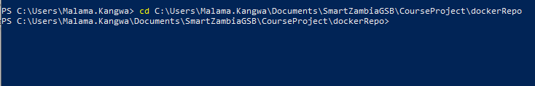

1. Pull the latest version of the image from Docker Hub using the command:

docker pull [image]

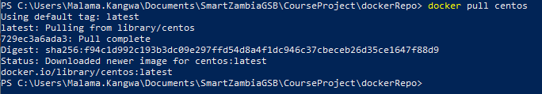

1. View the list of images using command:

docker images

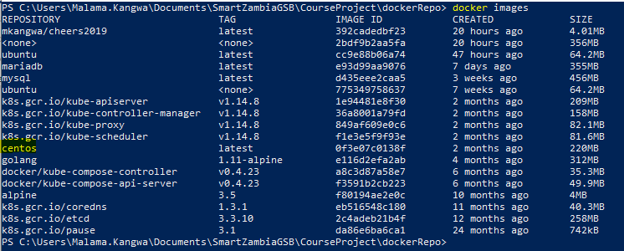

1. Create and run a container based on the created image using the command:

docker run [options] --name="[container name]" [image]

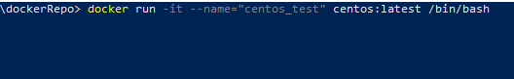

1. Create a directory and navigate to it using the commands:
2. mkdir [directory name]
3. cd [directory name]



1. Exit the container and return to the docker host using the command:

exit



1. Build a new image from the recently created docker container using the command:

docker commit -m="[Commit title]" [container name] [docker ID]/[repository name]



1. Run the images command again to ensure the new image has been created.

docker images

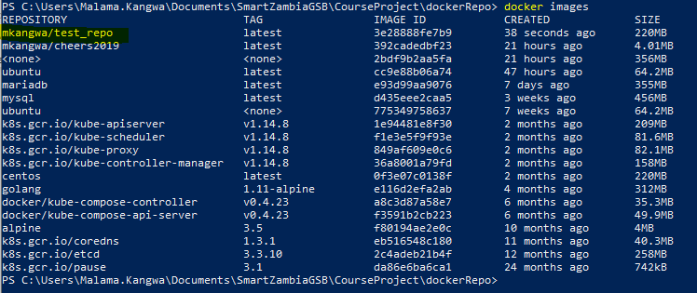

1. The next step will be to login to using the command:

docker login

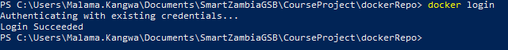

1. You can now push the docker the repository to docker hub using the command:

docker push [repository name]



1. Sing In to hub.Docker.com and view your repositories.

